**Practical No 5**

Aim: Demonstration of Analysis of Variance.

Theory: Analysis of variance (ANOVA) is an analysis tool used in statistics that splits an observed aggregate variability found inside a data set into two parts: systematic factors and random factors. The systematic factors have a statistical influence on the given data set, while the random factors do not.

Code :

# CREATE THE DATA IN TO THREE GROUPS TO PRINT THE BOXPLOT

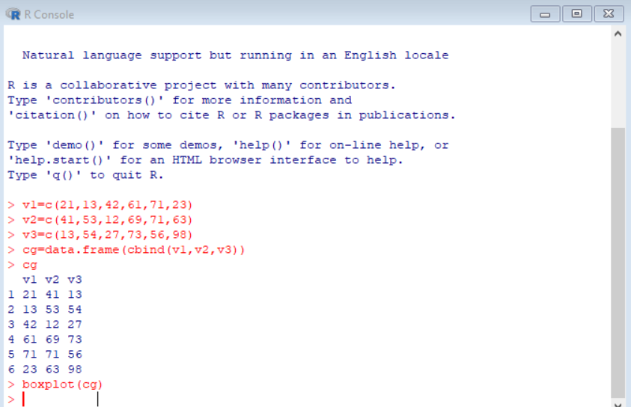

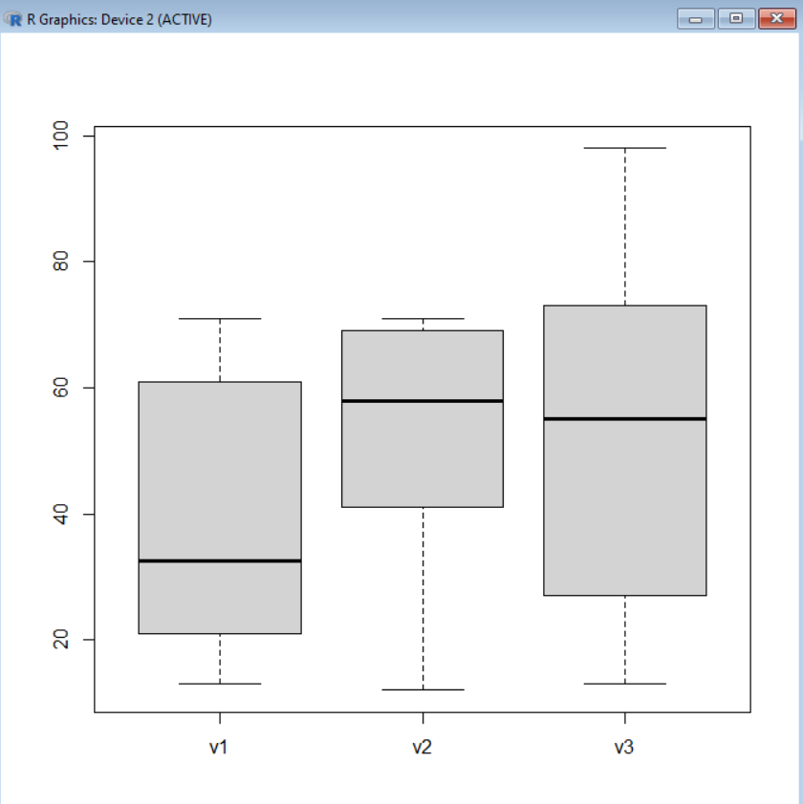

#TO PRINT THE DATA INTO STACK FORMATE

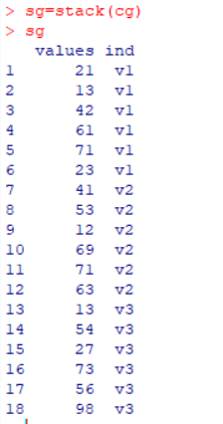

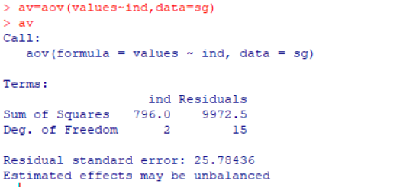 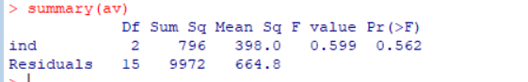

TAKE ANOTHER DATASET AND WORK ON THAT.

# CREATE THE DATA IN TO THREE GROUPS

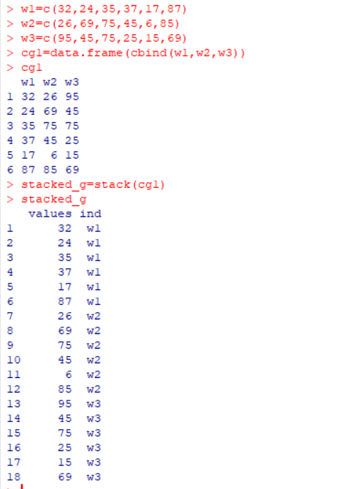

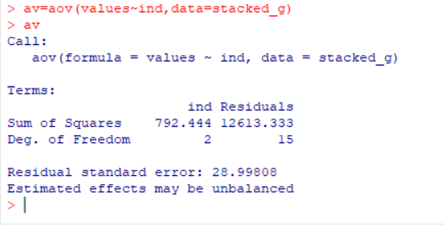

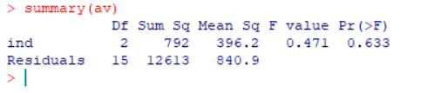

**Conclusion :** Successfully Implemented Varience……